Test Case: tc002_SPX_Dev5_Crear_Requisicion_Spot_Con_FAD_Tipo_Cobro_CC
Step 1 - Enter username and password and click to button Enter : Credentials Entered
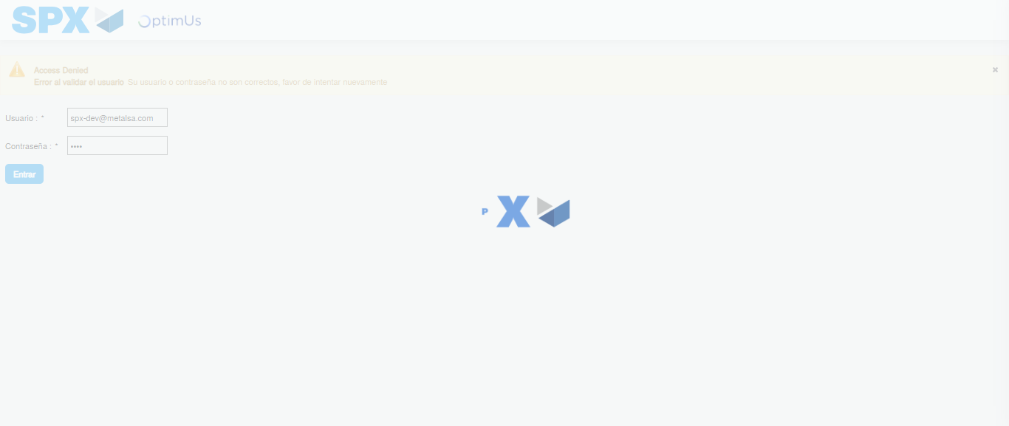Image file-name: QC_Testing-tc002_SPX_Dev5_Crear_Requisicion_Spot_Con_FAD_Tipo_Cobro_CC-1785343271016

Step 2 - Select to UEN and Access to Spot Buy Requisitions : UEN Correctly selected and Correct access
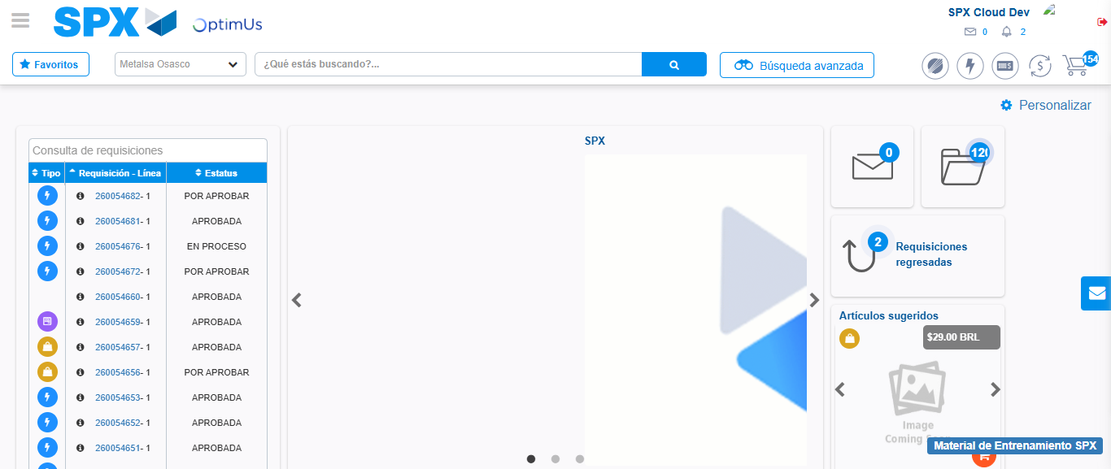Image file-name: QC_Testing-tc002_SPX_Dev5_Crear_Requisicion_Spot_Con_FAD_Tipo_Cobro_CC-1785343296044

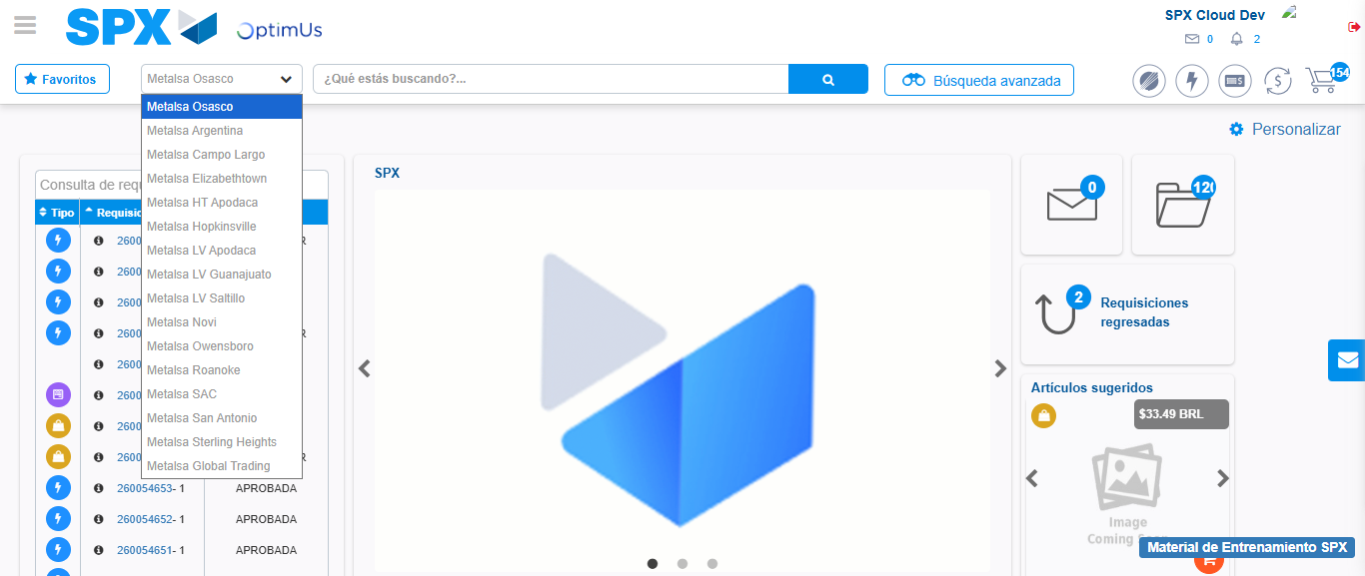Image file-name: QC_Testing-tc002_SPX_Dev5_Crear_Requisicion_Spot_Con_FAD_Tipo_Cobro_CC-1785343298676

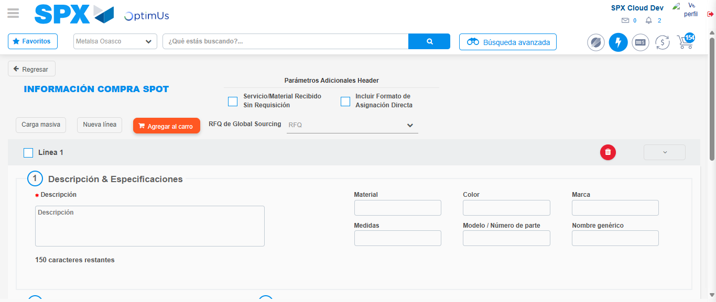Image file-name: QC_Testing-tc002_SPX_Dev5_Crear_Requisicion_Spot_Con_FAD_Tipo_Cobro_CC-1785343318560

Step 3 - Add FAD to Requisition: FAD Successfully Added
Image file-name: QC_Testing-tc002_SPX_Dev5_Crear_Requisicion_Spot_Con_FAD_Tipo_Cobro_CC-1785343318769

Image file-name: QC_Testing-tc002_SPX_Dev5_Crear_Requisicion_Spot_Con_FAD_Tipo_Cobro_CC-1785343318971

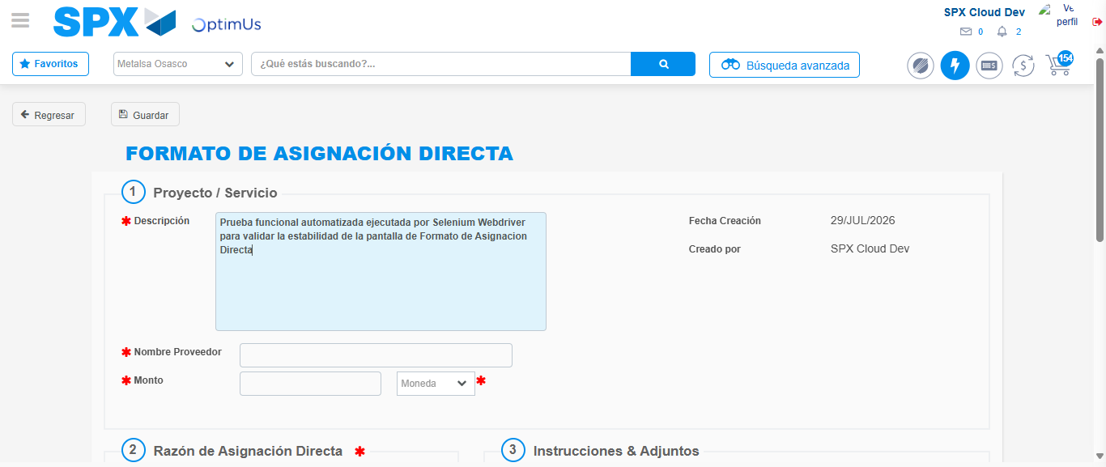Image file-name: QC_Testing-tc002_SPX_Dev5_Crear_Requisicion_Spot_Con_FAD_Tipo_Cobro_CC-1785343321765

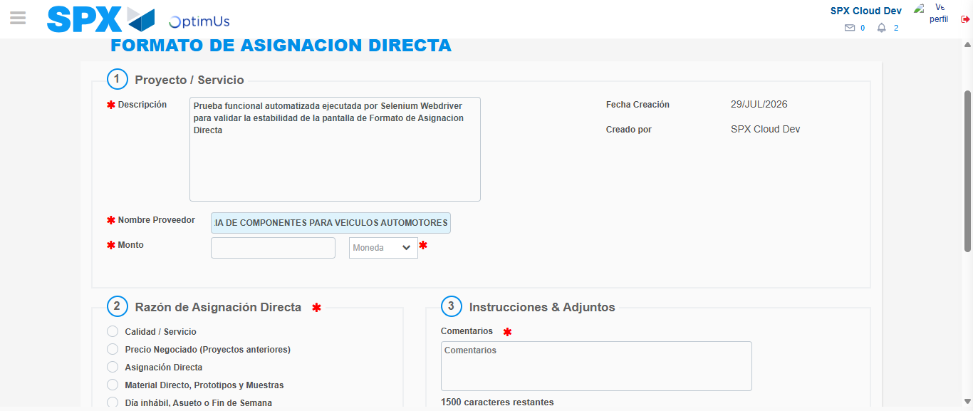Image file-name: QC_Testing-tc002_SPX_Dev5_Crear_Requisicion_Spot_Con_FAD_Tipo_Cobro_CC-1785343330844

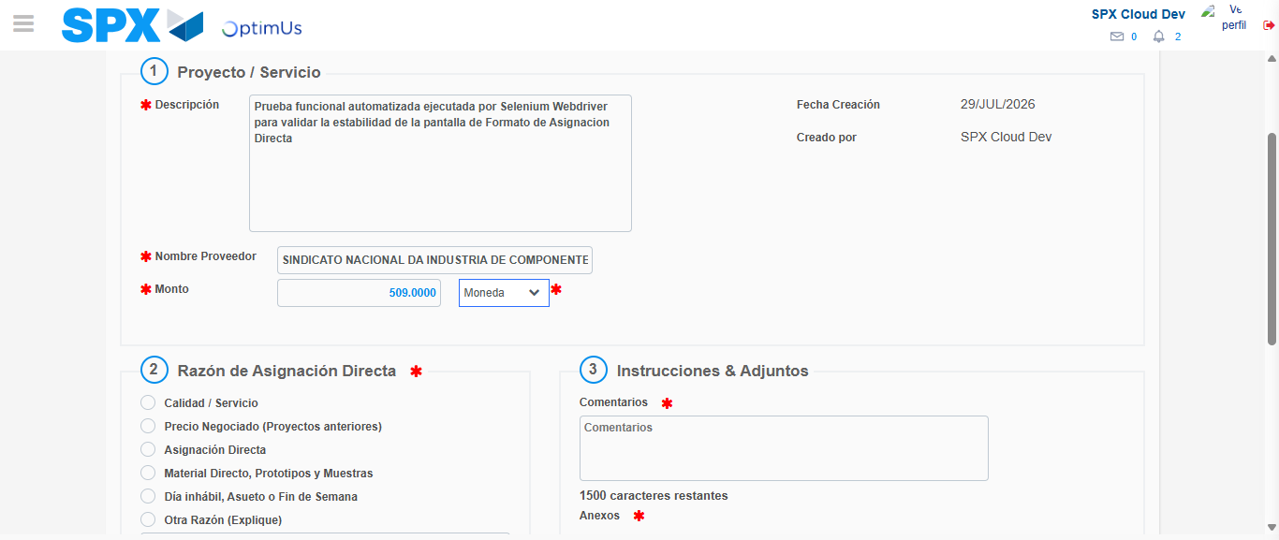Image file-name: QC_Testing-tc002_SPX_Dev5_Crear_Requisicion_Spot_Con_FAD_Tipo_Cobro_CC-1785343331210

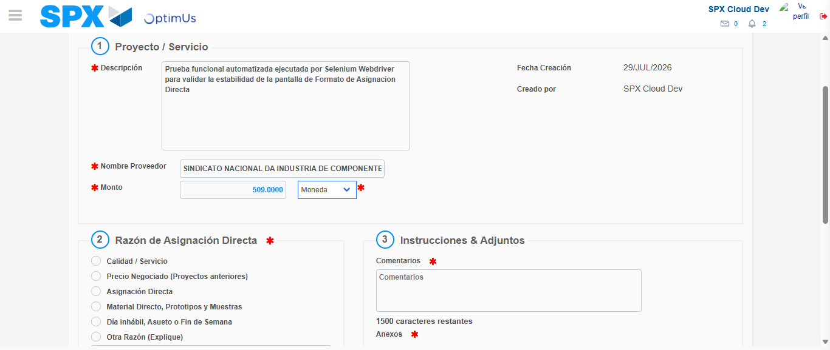Image file-name: QC_Testing-tc002_SPX_Dev5_Crear_Requisicion_Spot_Con_FAD_Tipo_Cobro_CC-1785343331406

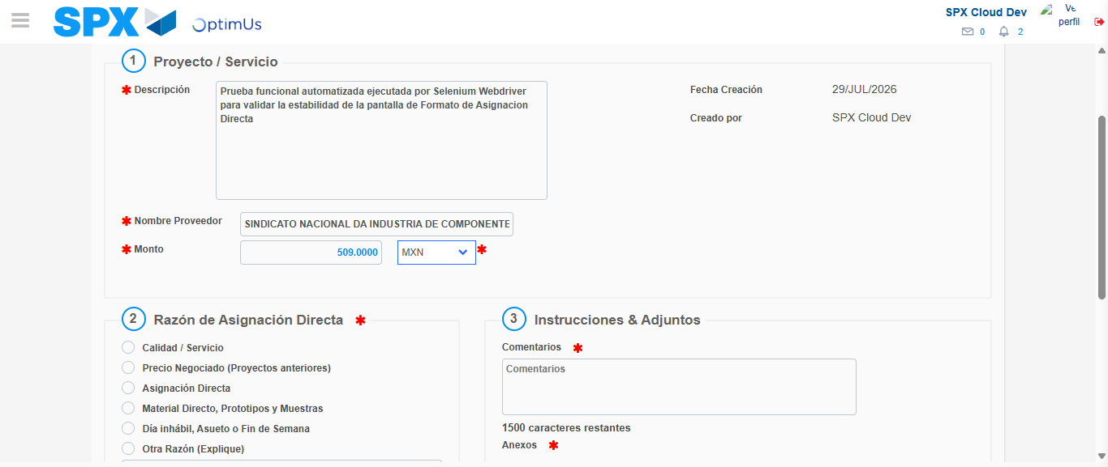Image file-name: QC_Testing-tc002_SPX_Dev5_Crear_Requisicion_Spot_Con_FAD_Tipo_Cobro_CC-1785343331798

Image file-name: QC_Testing-tc002_SPX_Dev5_Crear_Requisicion_Spot_Con_FAD_Tipo_Cobro_CC-1785343332009

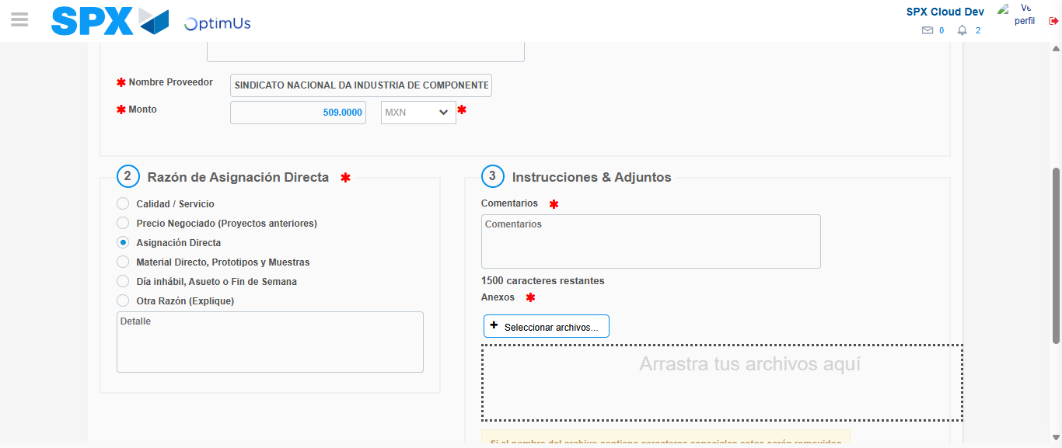Image file-name: QC_Testing-tc002_SPX_Dev5_Crear_Requisicion_Spot_Con_FAD_Tipo_Cobro_CC-1785343332839

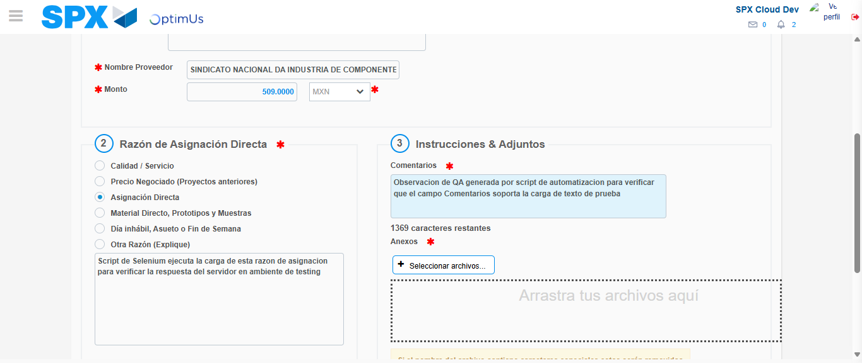Image file-name: QC_Testing-tc002_SPX_Dev5_Crear_Requisicion_Spot_Con_FAD_Tipo_Cobro_CC-1785343343880

Image file-name: QC_Testing-tc002_SPX_Dev5_Crear_Requisicion_Spot_Con_FAD_Tipo_Cobro_CC-1785343344583

Step 4 - Data Capture Spot Buy Requisition: Data captured correctly
Image file-name: QC_Testing-tc002_SPX_Dev5_Crear_Requisicion_Spot_Con_FAD_Tipo_Cobro_CC-1785343318769

Image file-name: QC_Testing-tc002_SPX_Dev5_Crear_Requisicion_Spot_Con_FAD_Tipo_Cobro_CC-1785343318971

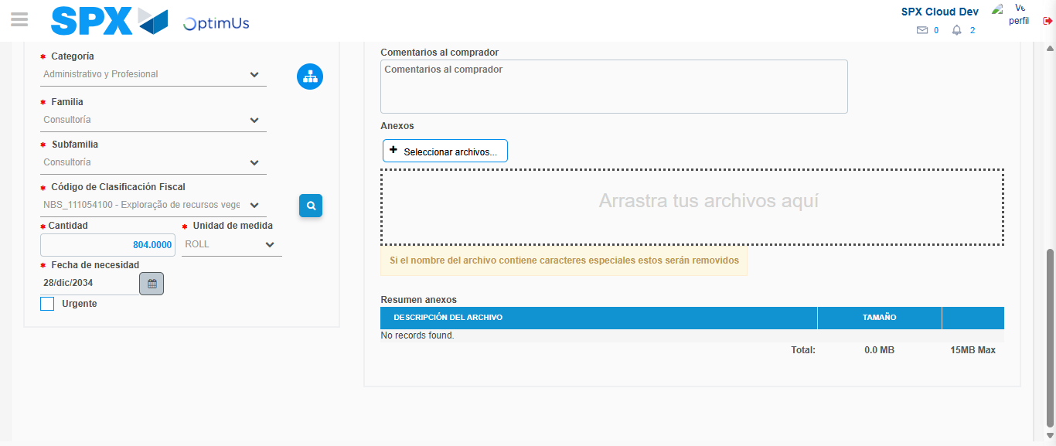Image file-name: QC_Testing-tc002_SPX_Dev5_Crear_Requisicion_Spot_Con_FAD_Tipo_Cobro_CC-1785343359092

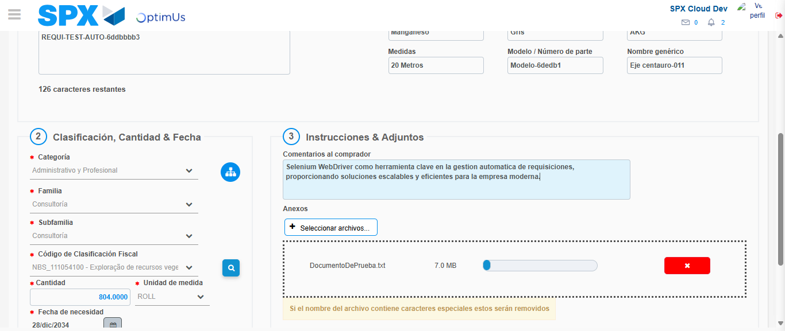Image file-name: QC_Testing-tc002_SPX_Dev5_Crear_Requisicion_Spot_Con_FAD_Tipo_Cobro_CC-1785343359827

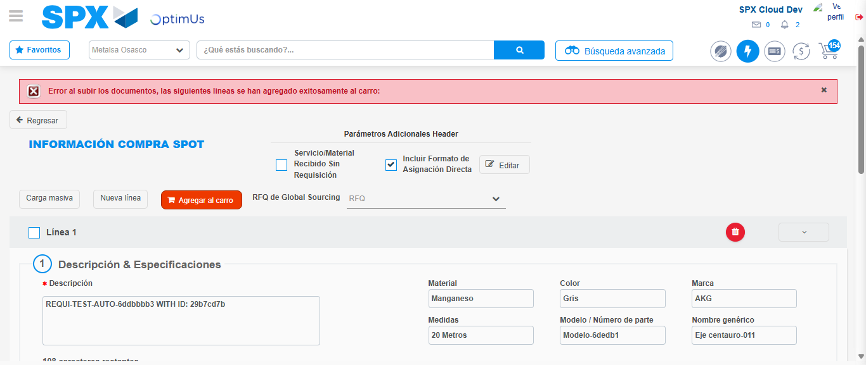Image file-name: QC_Testing-tc002_SPX_Dev5_Crear_Requisicion_Spot_Con_FAD_Tipo_Cobro_CC-1785343378022

Step 8 - Return to Main Page SPX : Return to Main Page SPX
Image file-name: QC_Testing-tc002_SPX_Dev5_Crear_Requisicion_Spot_Con_FAD_Tipo_Cobro_CC-1785343296044

Image file-name: QC_Testing-tc002_SPX_Dev5_Crear_Requisicion_Spot_Con_FAD_Tipo_Cobro_CC-1785343298676

Image file-name: QC_Testing-tc002_SPX_Dev5_Crear_Requisicion_Spot_Con_FAD_Tipo_Cobro_CC-1785343318560

Image file-name: QC_Testing-tc002_SPX_Dev5_Crear_Requisicion_Spot_Con_FAD_Tipo_Cobro_CC-1785343380263

Image file-name: QC_Testing-tc002_SPX_Dev5_Crear_Requisicion_Spot_Con_FAD_Tipo_Cobro_CC-1785343380450

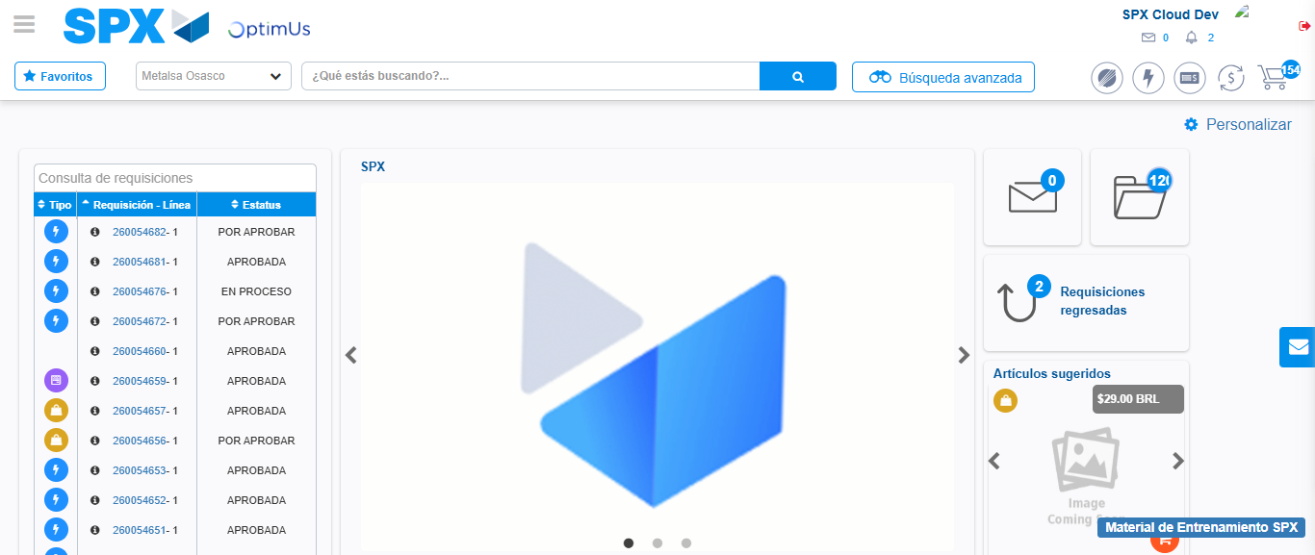Image file-name: QC_Testing-tc002_SPX_Dev5_Crear_Requisicion_Spot_Con_FAD_Tipo_Cobro_CC-1785343401444

Step 9 - Log Out : Log Out SPX
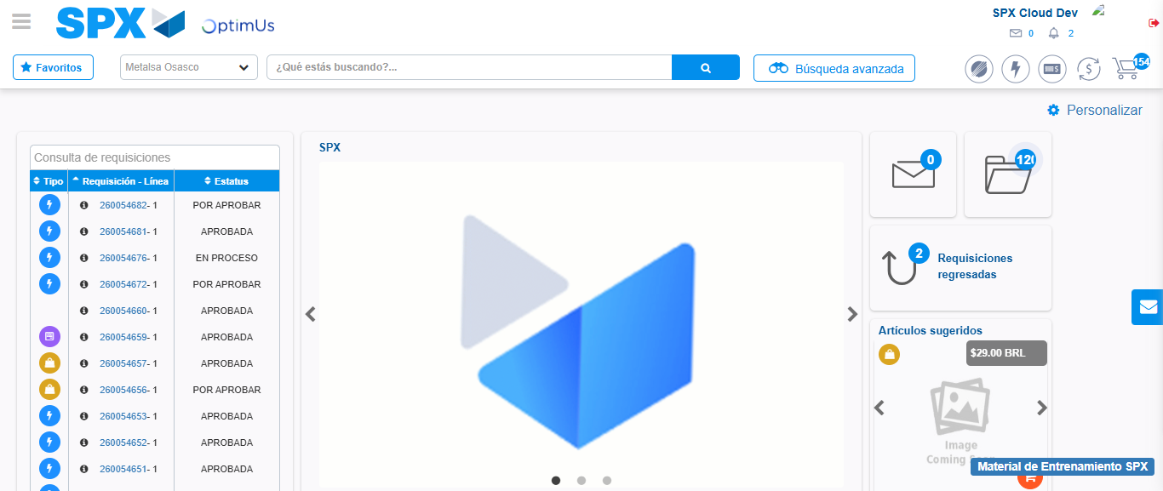Image file-name: QC_Testing-tc002_SPX_Dev5_Crear_Requisicion_Spot_Con_FAD_Tipo_Cobro_CC-1785343401707

